Ideation Phase
Brainstorm & Idea Prioritization Template

Date | 31 January 2025
Team ID | LTVIP2026TMIDS66355
Project Name | Laptop Request Catalog Item
Maximum Marks | 4 Marks

Brainstorm & Idea Prioritization Template:
Brainstorming provides an open environment that encourages team members to share creative ideas while developing a Laptop Request Catalog Item. It helps generate solutions for laptop request submission, approval workflows, configuration selection, delivery tracking, maintenance, and reporting. By prioritizing idea quantity over immediate evaluation, innovative concepts such as automated approvals, request dashboards, and notification alerts can be explored and refined collaboratively.
Use this template in brainstorming sessions so your team can exchange ideas, prioritize useful features, and design an efficient laptop request process even when working remotely.
Reference: https://www.mural.co/templates/brainstorm-and-idea-prioritization
Step-1: Team Gathering, Collaboration and Select the Problem Statement

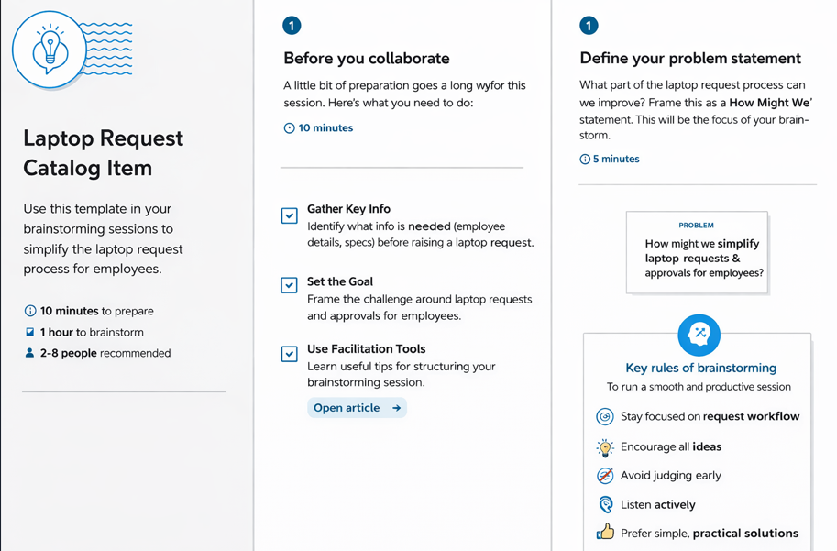

Step-2: Brainstorm, Idea Listing and Grouping
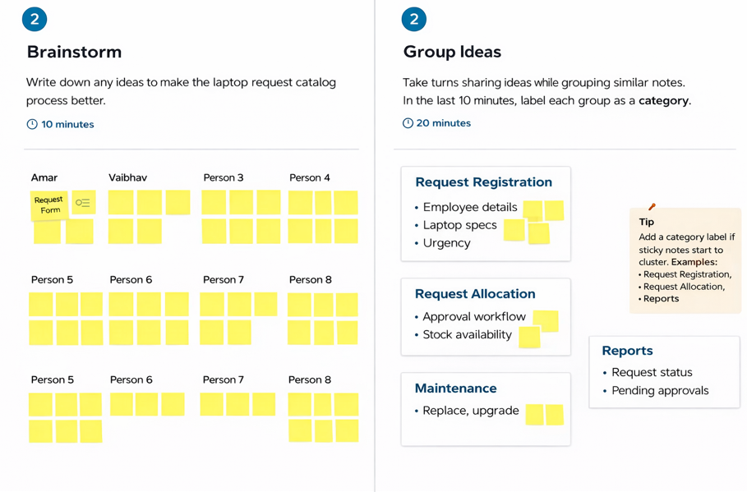
Step-3: Idea Prioritization
